SESSION-6

TASK-1
Create a simple Scrum Board for a 'Food Delivery App Testing' project using a spreadsheet or online tool (like Trello or Miro), with columns for Backlog, To Do, In Progress, and Done. Add at least 6 testing tasks such as 'Login Functionality Test', 'Order Placement Test', and 'Payment Gateway Test'.
ANSWER:
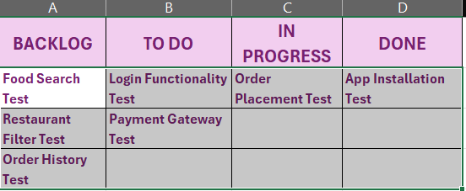
Explanation:
A Scrum Board helps the testing team keep track of their work and see the current status of each testing task. As a task is started or completed, it can be moved from Backlog → To Do → In Progress → Done.
Conclusion:
The Scrum Board makes the testing work more organized and helps the team easily understand which tasks are pending, being tested or completed.

TASK-2
Write a short description of what happens during a Sprint Review in Agile, and explain how the testing team contributes to this meeting using an example from any app you use (such as Zomato or Instagram).
ANSWER:
What happens during a Sprint Review?
A Sprint Review is a meeting held at the end of a Sprint where the team shows the completed work to the stakeholders. The team discusses what was completed, gets feedback nd decides what improvements or changes may be needed next.
Role of Testing Team
The testing team checks the completed features during the Sprint and shares the testing results in the Sprint Review. They can explain which features passed testing, what defects were found and whether the feature is ready to be shown to users.
Example - Zomato
Suppose the team has developed a new food-order tracking feature in Zomato. The tester checks whether the order status updates correctly, reports any bugs found and shares the testing status during the Sprint Review.
Conclusion:
The Sprint Review helps the team show their completed work, receive feedback and understand what needs to be improved. The testing team helps by providing the testing results and information about the quality of the feature.

TASK-3
List 5 typical Agile testing activities that would happen during a 2-week sprint for a new feature in a popular app (for example, adding 'Dark Mode' to WhatsApp). For each activity, mention which Scrum Board column it would appear in at the start of the sprint.
ANSWER:

No. | Agile Testing Activity | Scrum Board Column at the Start
1. | Review the requirements and understand how Dark Mode should work. | To Do
2. | Prepare test cases for Dark Mode, such as checking different screens and settings. | To Do
3. | Test Dark Mode on different screens and check whether it works correctly. | To Do
4. | Report any bugs found, such as text or buttons not being visible properly. | To Do
5. | Retest the fixed bugs and check that Dark Mode works properly after the fixes. | To Do

Conclusion:
Agile testing is done throughout the Sprint instead of waiting until the end. The testing team continuously checks the feature, reports bugs, and retests the fixes to make sure the feature is ready.

TASK-4
Pick any one feature from an app you use daily (like 'Add to Cart' in Flipkart or 'Stories' in Instagram) and break it down into at least 4 test tasks that would be tracked on a Scrum Board. Assign each task to a specific sprint day and explain your reasoning.
Hint: Think about functional, UI, and integration testing for the feature.
ANSWER:
Feature: Place Order
Sprint Day | Scrum Board Task | Testing Type | Reasoning
Day 1 | Check whether the user can select food items and place an order. | Functional Testing | First, I would check the basic ordering function to make sure it works correctly.
Day 2 | Check the order screen, buttons, food details, and total price. | UI Testing | I would make sure everything is clearly displayed and the user can easily understand the order screen.
Day 3 | Check whether the order is correctly connected with the payment system. | Integration Testing | I would check whether the order and payment work properly together.
Day 4 | Test different situations such as failed payment, removing an item, or changing the quantity. | Functional Testing | I would check how the feature behaves when the user does something unexpected or when an error occurs.

Explanation:
I divided the tasks across four Sprint days so that I can first check the basic functionality, then the UI, followed by the connection with payment and finally different or unexpected situations. This makes the testing more organized and helps find problems step by step.
Conclusion:
Breaking the feature into smaller tasks makes it easier for the testing team to track progress on the Scrum Board and complete testing within the Sprint.

